Information Technology Institute (ITI)

Smart Village

**Analyze And Model Data Warehouse**

**For Airline System Project**

**Prepared by:**

Amr El-saeed Mohamed Ellakany

Donia Ayman Ahmed

Hafsa Ahmed Zahran

Mohab Mahmoud Amro Abd Elghafar

Shahd Mohamed Ali

**Presented to:**

Ebtehal El-Hossiny

**Table of Contents**

**Contents**

Introduction 3

Business Matrix 3

Dimensional Modeling Process 3

1- Business process 3

2- Granularity 3

3- Dimensions Tables 3

4- Facts Tables: 4

Logical Model 5

Tables Identifications 6

1- Passengers Dimension 6

2- Frequent Flyers Dimension 6

3- Flights Dimension. 6

4- Class Upgrade Dimension. 6

5- Date Dimension. 6

6- Reservation Channels Dimension. 6

7- Fare Basis Dimension. 7

8- Hotels Dimension. 7

9- Interactions Dimension. 7

10- Aircrafts Dimension. 7

11- Airports Dimension. 7

12- Payment Methods Dimension. 7

13- Redeem Dimension. 8

14- Staff Dimension 8

15- Flights Activity Fact. 8

16- Customer Care Fact. 8

17- Frequent Flyers Fact. 9

Physical Model 9

Insert Dummy Data into The Physical Tables 23

Insert The Measured Data into Fact Tables 30

SQL Queries to Answer Business Questions: 33

Indexes For the Data Warehousing 38

## Introduction

The project’s purpose is to analyze the flight activities of some airline companies and their frequent flyers and model its data warehouse schema.

## Business Matrix

## Dimensional Modeling Process

### Business process

Analyze the Airlines flights’ activities.

### Granularity

Flights Activity Fact is per Leg level.

Customer Care Fact is per Ticket Number level.

Frequent Flyers Fact is per Ticket Number level.

### Dimensions Tables

1. Passengers Dimension.
2. Frequent Flyers Dimension.
3. Flights Dimension.
4. Date Dimension.
5. Class Upgrade Dimension.
6. Channels Dimension.
7. Fare Basis Dimension.
8. Hotels Dimension.
9. Interactions Dimension.
10. Airports Dimension
11. Aircrafts Dimension
12. Payment methods Dimension
13. Redeem Dimension
14. Staff Dimension

### Facts Tables:

1. Flights Activity Fact.
2. Frequent Flyers Fact
3. Customer Care Fact.

## Logical Model

Represents the facts and dimensions tables, and the relations between them.

## Tables Identifications

### Passengers Dimension

Represents data about passengers, like **Passenger** **ID**, **Name, Gender,** **Phone Number, email, address, city, country**, **Passenger Type**: **Regular or Frequent.**

### Frequent Flyers Dimension

Represents data about Frequent Flyers, like **Their ID**, **Tier, Club Membership Status: Non Member, Club Member, Mileage Tier and Membership Status**

**As follow:**

**Under 100,000 miles Silver**

**500,000-1,999,999 miles Platinum**

**100,000-499,999 miles Gold**

### Flights Dimension.

Represents data about the flight, like **flight ID**, **Flight Zone: Domestic or international and Flight type: Non-Stop, Direct, indirect.**

### Class Upgrade Dimension.

Represents data about the flight, like **ID**, **Purchased class: Economy, Prem Economy, First, Business and Flown Class, purchased Flown Group** **Economy-Economy, Economy-Prem Economy,…etc, class change indicator: No change , Upgrade, Downgrade**

### Date Dimension.

Represents the **Minute**, **Hour**, **Day**, **Month**, **Quarter**, and **Year** for each date stored for different business needs.

### Reservation Channels Dimension.

Represents the channel that the ticket was purchased from. Like **channel Id**, **channel type** It can be **Website** **or the agency itself.**

### Fare Basis Dimension.

Represents if the passenger fully paid the ticket price, or with a discount. It contains **id, code, status.**   
This represented using code numbers which:

**111 means Full Fare First Class.  
112 means Discount Fare First Class.  
221 means Full Fare Business Class.  
222 means Discount Fare Business Class.  
331 means Full Fare Economy Class.  
332 means Discount Fare Economy Class.**

### Hotels Dimension.

Represents data about the hotels that the passengers stayed on during the transit flights, like hotel ID, Stars, Night Price, city and country.

### Interactions Dimension.

Represents the passenger’s different interactions with customer services, it contains the **Interaction Time** if it was **Before**, **Within**, or **After** the flight and the **Interaction Type** if it was **Feedback**, **Inquiry**, or **Complaint.**

### Aircrafts Dimension.

Represents the data about the aircraft, it contains **ID, Model, Company and Seats Capacity**

### Airports Dimension.

Represents the information about airport, it contains **ID, Name , City and Country**

### Payment Methods Dimension.

Represents the information about the payment method, it contains **Payment method type: Credit or Cash**

### Redeem Dimension.

Represents the information about the type of Redeem that customer will change his mile point with, it contains **type and description.**

**As follow:**

**Flight awards Get a discount on your ticket total price.**

**Upgrade awards Get premium cabin upgrades.**

**Club and status awards Complimentary amenities and services are**

**available to make your travel more productive**

**and relaxing.**

### Staff Dimension

Represents the information about staff like: **ID, Name, Gender, Address, job title, department, phone and his supervisor.**

### Flights Activity Fact.

Represents the activity of the passenger during the flight and the data needed.

### Customer Care Fact.

Represents the passenger’s different **interactions** and the customer service’s employee who is responsible for it and in which flight this interaction happened and the passenger’s seat number and his ticket’s number.It measures the **Problem Severity** based on its **Type** and **Time** of the occurrence to work on different interactions based on their priorities:

**6 for Complaint Within the flight.  
4 for Complaint Before the flight.  
2 for Complaint After the flight.  
6 for Inquiry Within the flight.  
4 for Inquiry Before the flight.  
2 for Inquiry After the flight.**

It also shows the passengers’ **feedback rate [From 1 ~ 5]**

### Frequent Flyers Fact.

Represents the frequent flyers process and the **Miles Earned** that each passenger gained based on the **Miles Flown** also shows the **redeem type** to change these miles and the **promotion response**.

## Physical Model

The creation of tables using SQL queries. In this project, PL SQL is used for all queries.

1. **Create Passenger Dimension**

CREATE TABLE Passengers_Dim

(

Passenger_key NUMBER CONSTRAINT Passenger_pk_cons PRIMARY KEY,

Passenger_ID VARCHAR2(250) CONSTRAINT Passenger_ID_unq UNIQUE,

Name VARCHAR2(250),

Gender VARCHAR2(50),

Phone VARCHAR2(250),

Email VARCHAR2(250),

Passenger_Type VARCHAR2(100),

Address VARCHAR2(250),

City VARCHAR2(250),

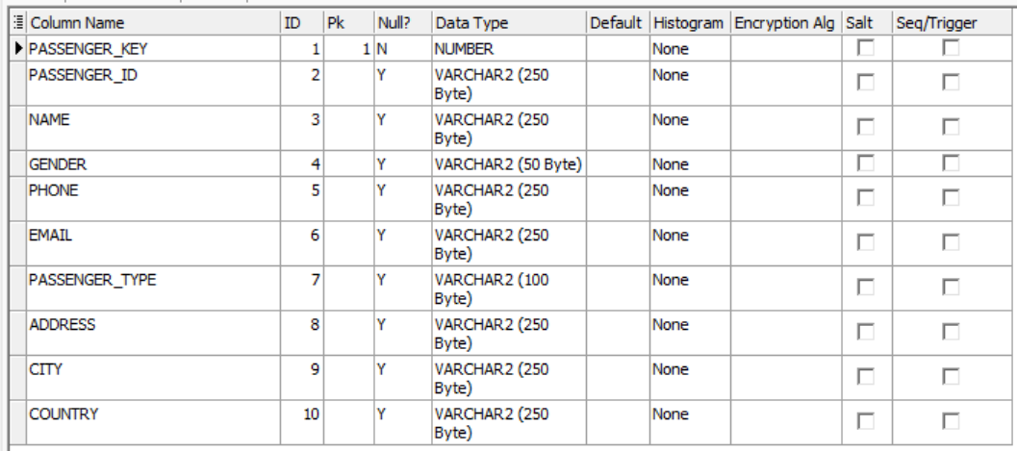 Country VARCHAR2(250) );

1. **Create Frequent Flyers Dimension**

CREATE TABLE Frequent_flyers_Dim

(

Freq_key NUMBER CONSTRAINT Freq_pk_cons PRIMARY KEY,

Freq_ID VARCHAR2(250) CONSTRAINT Freq_ID_unq UNIQUE,

Tier VARCHAR2(250),

Club_Membership_Status VARCHAR2(250),

Milage_Tier VARCHAR2(250),

Mempership_Status VARCHAR2(250)

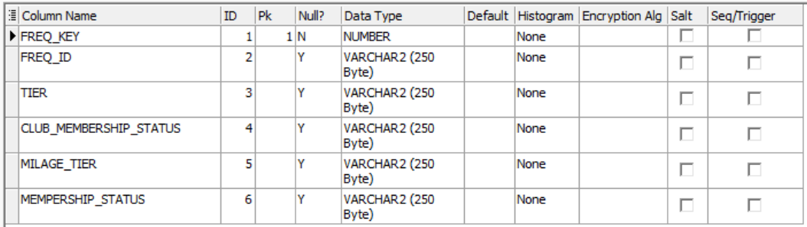);

1. **Create Flights Dimension**

CREATE TABLE Flights_Dim

(

Flight_key NUMBER CONSTRAINT flight_pk_cons PRIMARY KEY,

Flight_ID VARCHAR2(250) CONSTRAINT flight_unq_cons UNIQUE,

Flight_zone VARCHAR2(250),

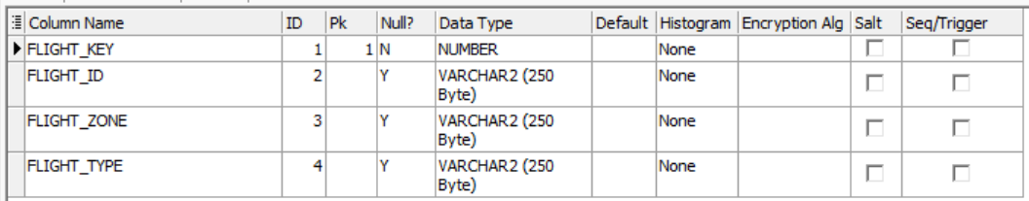 Flight_type VARCHAR2(250) );

1. **Create Class Upgrade Dimension**

CREATE TABLE Class_Upgrade_Dim

(

Class_Upgrade_key NUMBER CONSTRAINT class_pk_cons PRIMARY KEY,

Class_Upgrade_ID VARCHAR2(250) CONSTRAINT classU_ID_unq UNIQUE,

Purchased_Class VARCHAR2(250),

Flown_Class VARCHAR2(250),

Purchased_Flown_Group VARCHAR2(250),

Class_Change_Indicator VARCHAR2(100)

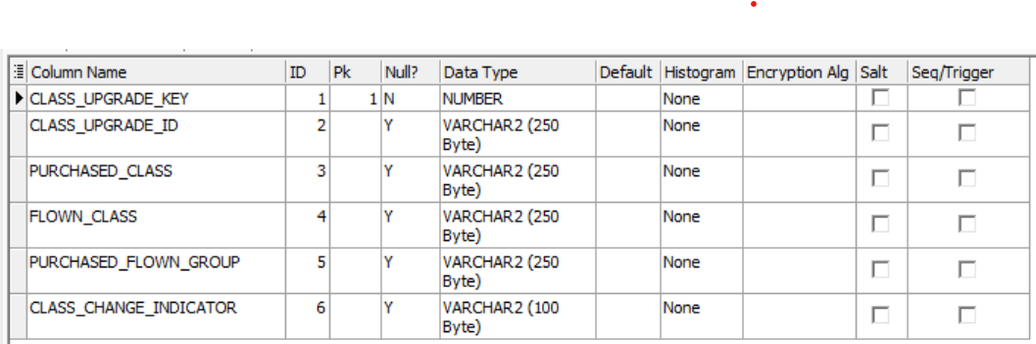);

1. **Create Date Dimension**

CREATE TABLE Date_Dim

(

Full_date DATE CONSTRAINT D_pk_cons PRIMARY KEY,

Year VARCHAR2(15),

Quarter VARCHAR2(15),

Month_Name VARCHAR2(15),

Week_of_Year NUMBER(6),

Week_of_Month NUMBER(6),

Day_Name VARCHAR2(20),

Day_Number NUMBER(6)

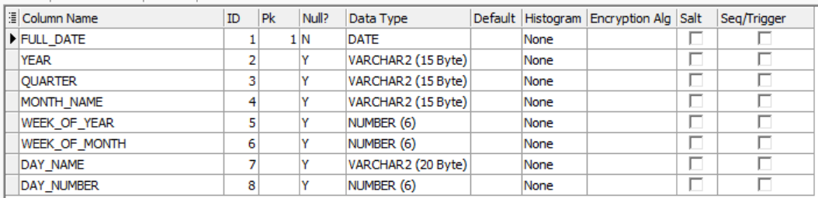 );

1. **Create Channel Dimension**

CREATE TABLE Channels_Dim

(

Channel_key NUMBER CONSTRAINT channel_pk_cons PRIMARY KEY,

Channel_Type VARCHAR2(200)

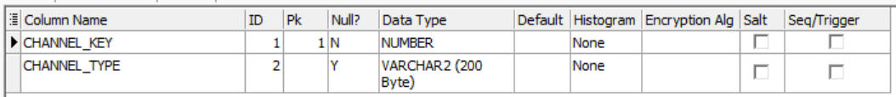 );

1. **Create Fare Basis Dimension**

CREATE TABLE Fare_Basis_Dim

(

Fare_Basis_key NUMBER CONSTRAINT fare_pk_cons PRIMARY KEY,

Status VARCHAR2(400),

Code VARCHAR2(100),

Promotion VARCHAR2(150)

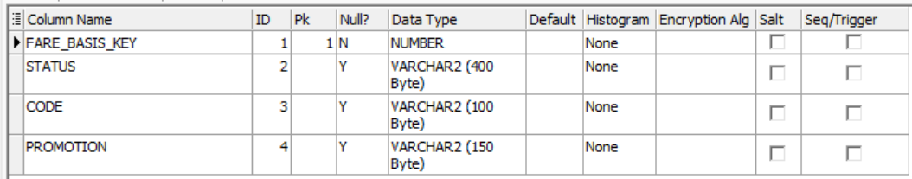);

1. **Create Hotel Dimension**

CREATE TABLE Hotels_DIM

(

Hotel_key NUMBER CONSTRAINT HT_pk_cons PRIMARY KEY,

Hotel_ID VARCHAR2(50) CONSTRAINT HT_unq_cons UNIQUE,

Stars NUMBER,

Night_Price NUMBER,

City VARCHAR2(20),

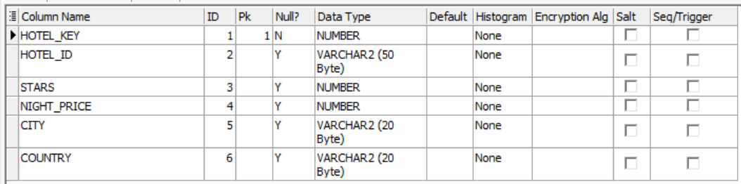 Country VARCHAR2(20) );

1. **Create Interactions Dimension**

CREATE TABLE Interactions_DIM

(

Interaction_key NUMBER CONSTRAINT Int_pk_cons PRIMARY KEY,

TYPE VARCHAR2(500),

Interaction_time VARCHAR2(150),

Description VARCHAR2(600)

);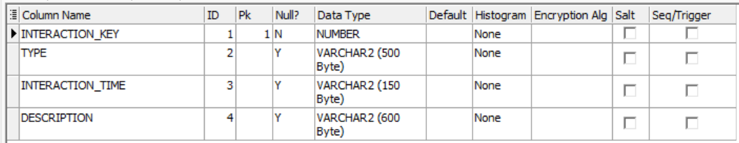

1. **Create Aircrafts Dimension**

CREATE TABLE Aircrafts_Dim

(

Aircraft_key NUMBER CONSTRAINT aircraft_pk_cons PRIMARY KEY,

Aircraft_ID VARCHAR2(100) CONSTRAINT Acraft_unq_cons UNIQUE,

Model VARCHAR2(100),

Company VARCHAR2(100),

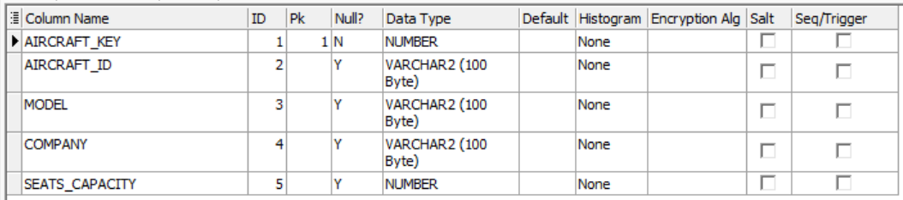 Seats_Capacity NUMBER  
);

1. **Create Airports Dimension**

CREATE TABLE Airports_Dim

(

Airport_key number CONSTRAINT airport_pk_cons PRIMARY KEY,

Airport_ID VARCHAR2(100) CONSTRAINT Aport_unq_cons UNIQUE,

Airport_name VARCHAR2(100),

City VARCHAR2(100),

Country VARCHAR2(100)

);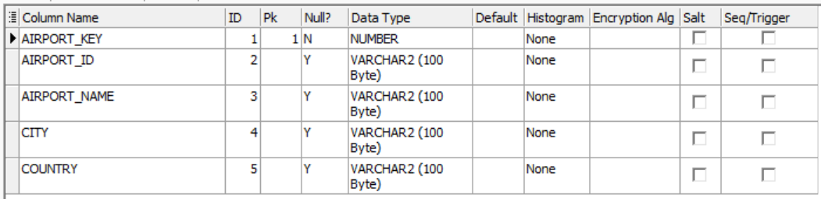

1. **Create Payment methods Dimension**

CREATE TABLE Payment_Methods_Dim

(

P_M_key NUMBER CONSTRAINT p_m_pk_cons PRIMARY KEY,

Payment_type VARCHAR2(100)

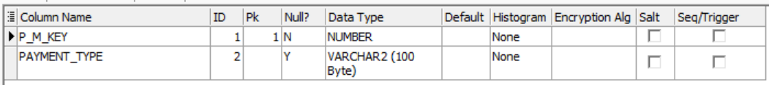);

1. **Create Redeem Dimension**

CREATE TABLE Redeem_Dim

(

Redeem_key NUMBER CONSTRAINT Rd_pk_cons PRIMARY KEY,

TYPE VARCHAR2(250),

Description VARCHAR2(500)

);  
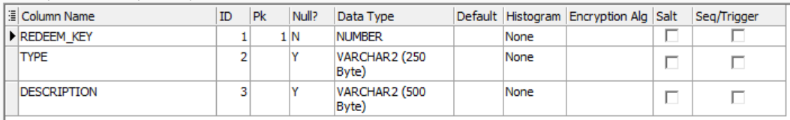

1. **Create Staff Dimension:**

CREATE TABLE Staff_Dim

(

Staff_key NUMBER CONSTRAINT ST_pk_cons PRIMARY KEY,

Staff_ID VARCHAR2(500) CONSTRAINT ST_unq_cons UNIQUE,

NAME VARCHAR2(500),

Gender VARCHAR2(20),

Address VARCHAR2(250),

Job_Title VARCHAR2(250),

Department VARCHAR2(250),

Phone VARCHAR2(15),

Supervisor VARCHAR2(80));   
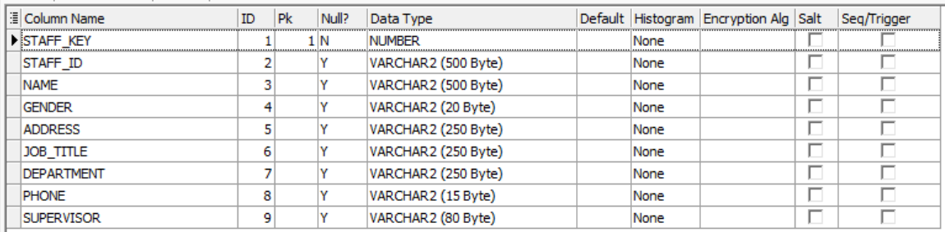

1. **Create Flights Activity Fact**

CREATE TABLE flights_activity_Fact

(

Leg_key NUMBER CONSTRAINT Leg_pk_cons PRIMARY KEY,

Ticket_number NUMBER CONSTRAINT TN_unq_cons UNIQUE,

Passenger_key NUMBER,

Freq_key NUMBER,

Aircraft_key NUMBER,

Segment_number NUMBER ,

Flight_key NUMBER,

Departure_airport NUMBER,

Arrival_airport NUMBER,

Actual_departure_date DATE,

Schedualed_departure_time TIMESTAMP,

Actual_departure_time TIMESTAMP,

Actual_arrival_date DATE,

Schedualed_arrival_time TIMESTAMP,

Actual_arrival_time TIMESTAMP,

Flight_duration NUMBER,

Reservation_Ticket_Date DATE,

Channel_key NUMBER,

Payment_method_key NUMBER,

Fare_basis_key NUMBER,

Class_upgrade_key NUMBER,

Luggage_Number NUMBER,

Base_fare_price NUMBER,

Taxes NUMBER,

Overweight_Luggage_price NUMBER,

Upgrage_fees NUMBER,

Transaction_fees NUMBER,

Promotion_amount NUMBER,

Net_price NUMBER,

Cost NUMBER,

Profit NUMBER,

Hotel_key NUMBER,

overnight_stays NUMBER

);

ALTER TABLE flights_activity_Fact

ADD(

CONSTRAINT pass_fk_cons FOREIGN KEY(Passenger_key) REFERENCES Passengers_Dim(Passenger_key),

CONSTRAINT FF_fk_cons FOREIGN KEY(Freq_key) REFERENCES Frequent_flyers_Dim(Freq_key),

CONSTRAINT aircraft_fk_cons FOREIGN KEY(aircraft_key) REFERENCES Aircrafts_Dim(Aircraft_key),

CONSTRAINT flight_fk_cons FOREIGN KEY(Flight_key) REFERENCES Flights_Dim(Flight_key),

CONSTRAINT airport_fk_cons FOREIGN KEY(Departure_airport) REFERENCES Airports_Dim(Airport_key),

CONSTRAINT airport_fk_conss FOREIGN KEY(Arrival_airport) REFERENCES Airports_Dim(Airport_key),

CONSTRAINT actual_date_departure_fk_cons FOREIGN KEY(Actual_departure_date) REFERENCES Date_Dim(Full_date),

CONSTRAINT actual_date_arrival_fk_cons FOREIGN KEY(Actual_arrival_date) REFERENCES Date_Dim(Full_date),

CONSTRAINT resv_t_date_fk_conssss FOREIGN KEY(Reservation_Ticket_Date) REFERENCES Date_Dim(Full_date),

CONSTRAINT ch_fk_conss FOREIGN KEY(Channel_key) REFERENCES Channels_Dim(Channel_key),

CONSTRAINT pm_fk_conss FOREIGN KEY(Payment_method_key) REFERENCES Payment_Methods_Dim(P_M_key),

CONSTRAINT fb_fk_conss FOREIGN KEY(Fare_basis_key) REFERENCES Fare_Basis_Dim(Fare_Basis_key),

CONSTRAINT cu_fk_conss FOREIGN KEY(Class_upgrade_key) REFERENCES Class_Upgrade_Dim(Class_Upgrade_key),

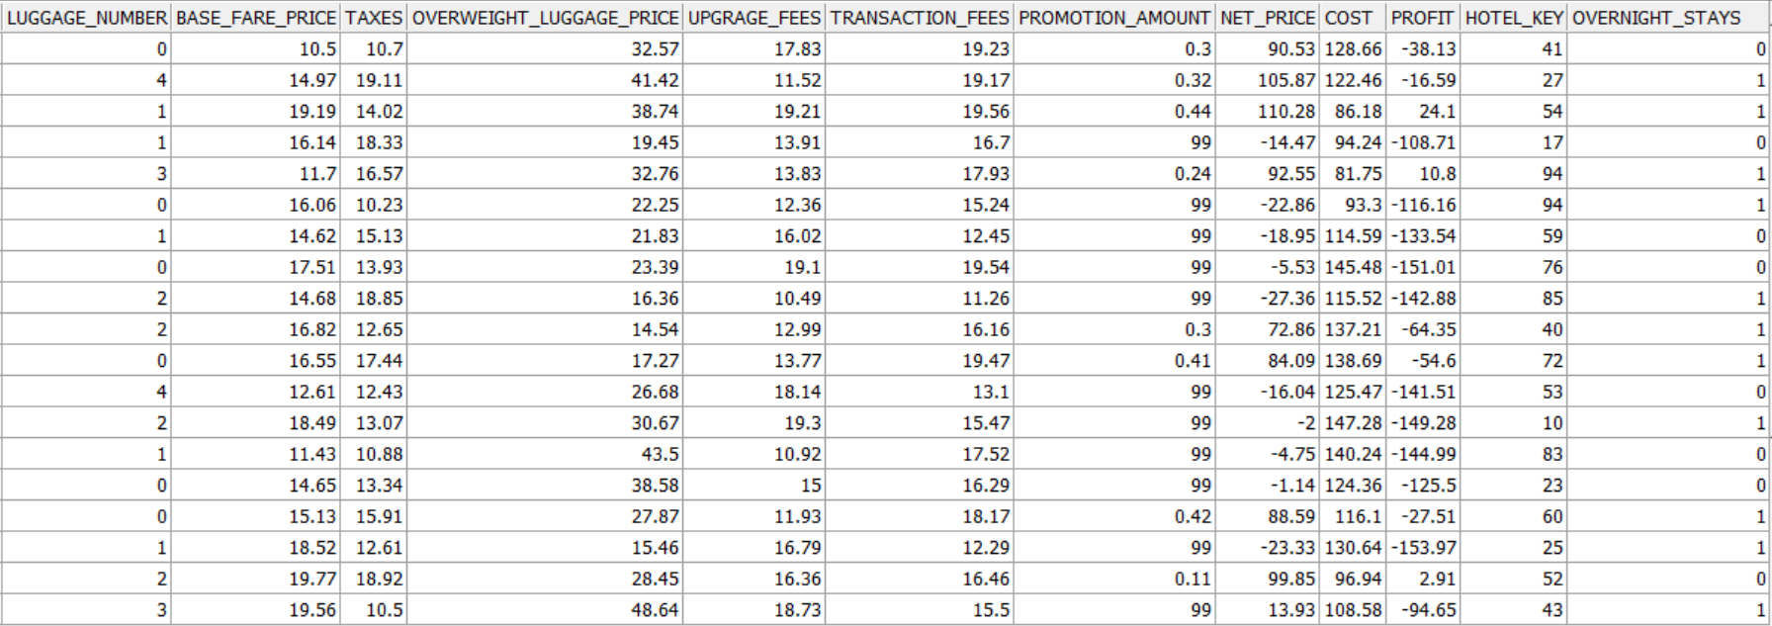 CONSTRAINT H_fk_consss FOREIGN KEY(Hotel_key) REFERENCES Hotels_DIM(Hotel_key) );

1. **Create Customer Care Fact**

CREATE TABLE Customer_Care_fact

(

CC_key NUMBER CONSTRAINT cc_pk_cons PRIMARY KEY ,

Ticket_number NUMBER CONSTRAINT TN_unq_consss UNIQUE,

Passenger_key NUMBER ,

Freq_key NUMBER ,

Reservation_Ticket_Date DATE,

Segment_number NUMBER,

Flight_key NUMBER,

Interaction_key NUMBER,

Staff_key NUMBER,

Problem_severity NUMBER,

Feedback_Rate NUMBER,

Deprature_airport NUMBER,

Arrival_airport NUMBER,

Seat_Number NUMBER

);

ALTER TABLE Customer_Care_fact

ADD(

CONSTRAINT pass_fk_consss FOREIGN KEY(Passenger_key) REFERENCES Passengers_Dim(Passenger_key),

CONSTRAINT FF_fk_consss FOREIGN KEY(Freq_key) REFERENCES Frequent_flyers_Dim(Freq_key),

CONSTRAINT resv_t_date_fk_consss FOREIGN KEY(Reservation_Ticket_Date) REFERENCES Date_Dim(Full_date),

CONSTRAINT flight_fk_consss FOREIGN KEY(Flight_key) REFERENCES Flights_Dim(Flight_key),

CONSTRAINT int_fk_consss FOREIGN KEY(Interaction_key) REFERENCES Interactions_DIM(Interaction_key),

CONSTRAINT st_fk_consss FOREIGN KEY(Staff_key) REFERENCES Staff_Dim(Staff_key),

CONSTRAINT airport_fk_consssss FOREIGN KEY(Deprature_airport) REFERENCES Airports_Dim(Airport_key),

CONSTRAINT airport_fk_conssssssss FOREIGN KEY(Arrival_airport) REFERENCES Airports_Dim(Airport_key)

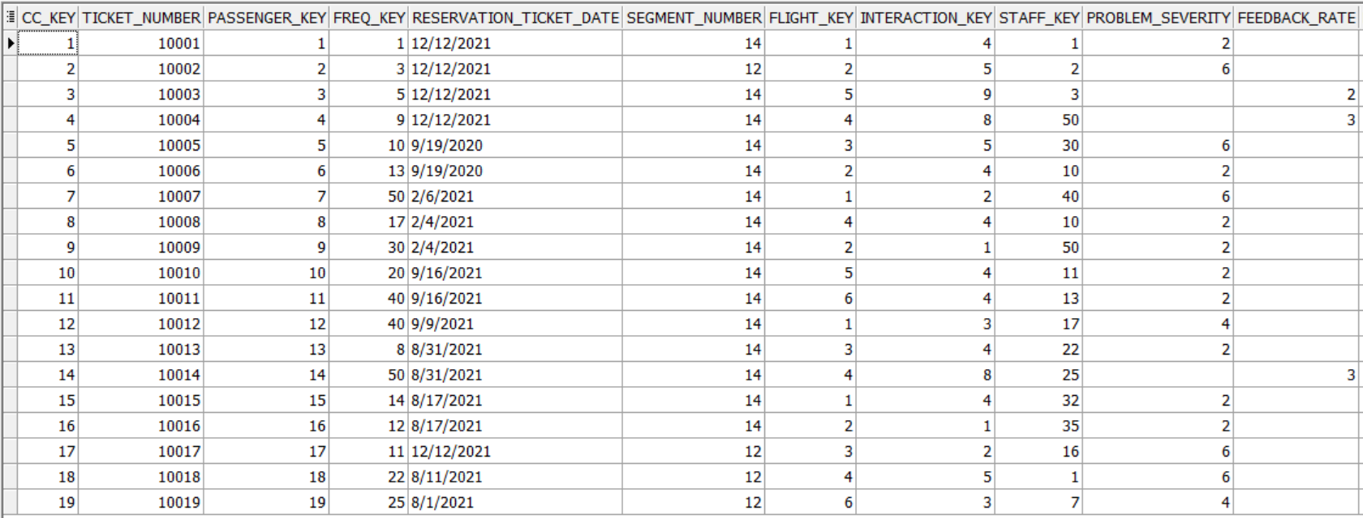 );

1. **Create Frequent Flyers Fact**

CREATE TABLE Frequent_Flyers_fact

(

FF_Fact_key Number CONSTRAINT freqf_fact_pk_cons PRIMARY KEY ,

Ticket_number NUMBER CONSTRAINT TTN UNIQUE,

Freq_key NUMBER,

Flight_date DATE,

Flight_key NUMBER,

Deprature_airport NUMBER,

Arrival_airport NUMBER,

Miles_flown NUMBER,

Miles_earned NUMBER,

promotion_response VARCHAR2(20),

Redeem_key NUMBER

);

ALTER TABLE Frequent_Flyers_fact

ADD(

CONSTRAINT FF_fk_conssss FOREIGN KEY(Freq_key) REFERENCES Frequent_flyers_Dim(Freq_key),

CONSTRAINT f_date_fk_consss FOREIGN KEY(Flight_date) REFERENCES Date_Dim(full_date),

CONSTRAINT flight_fk_conssss FOREIGN KEY(Flight_key) REFERENCES Flights_Dim(Flight_key),

CONSTRAINT airport_fk_consssssssss FOREIGN KEY(Deprature_airport) REFERENCES Airports_Dim(Airport_key),

CONSTRAINT airport_fk_consssssssssss FOREIGN KEY(Arrival_airport) REFERENCES Airports_Dim(Airport_key),

CONSTRAINT rd_fk_consss FOREIGN KEY(Redeem_key) REFERENCES Redeem_Dim(Redeem_key)

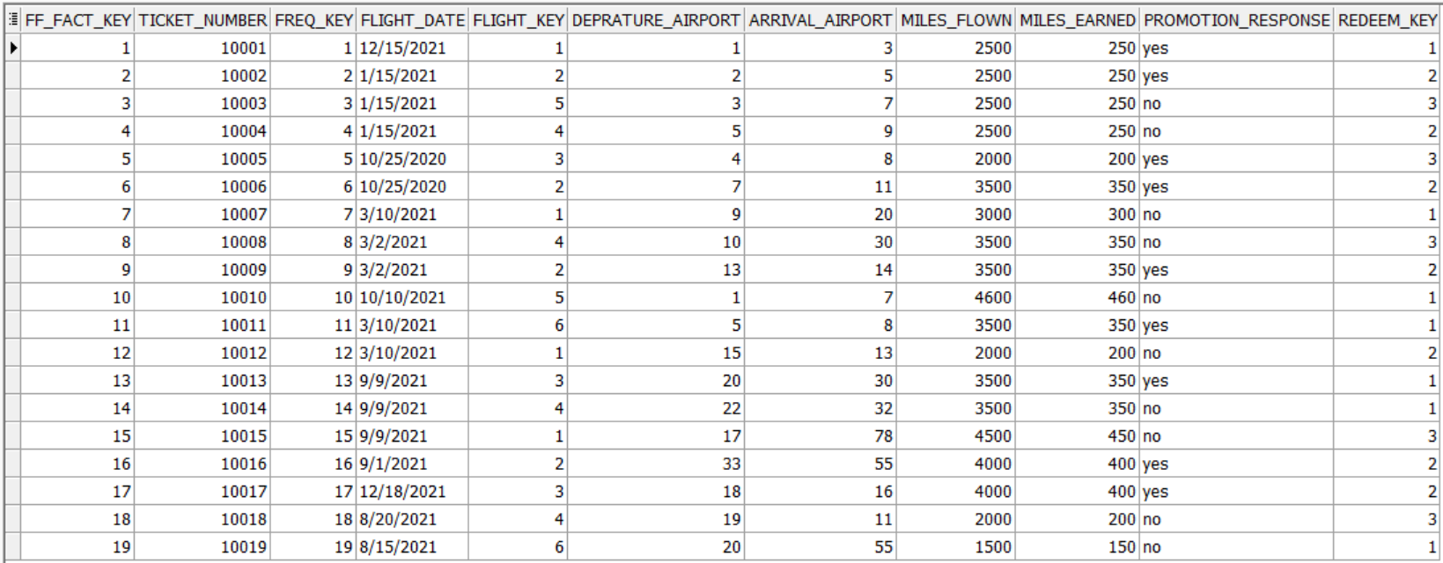 );

## Insert Dummy Data into The Physical Tables

The data inserted was using excel files that have dummy data and PLSQL blocks generating random data

1. Passengers Dimension Data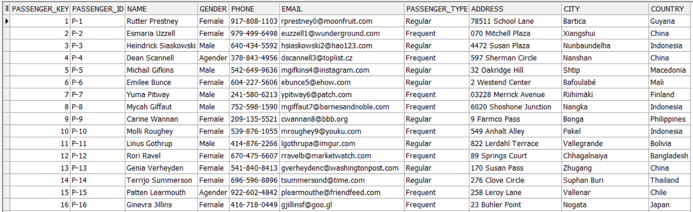
2. Frequent Flyers Dimension Data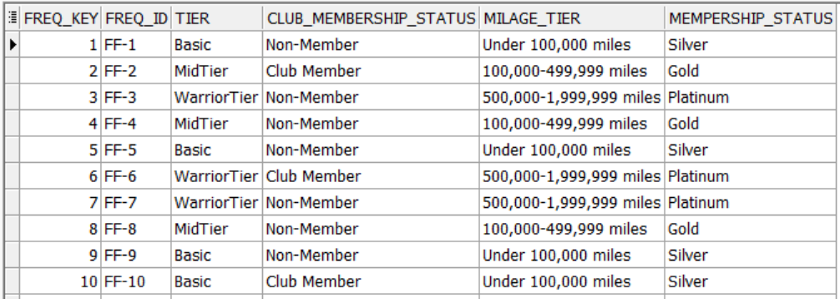
3. Class Upgrade Dimension Data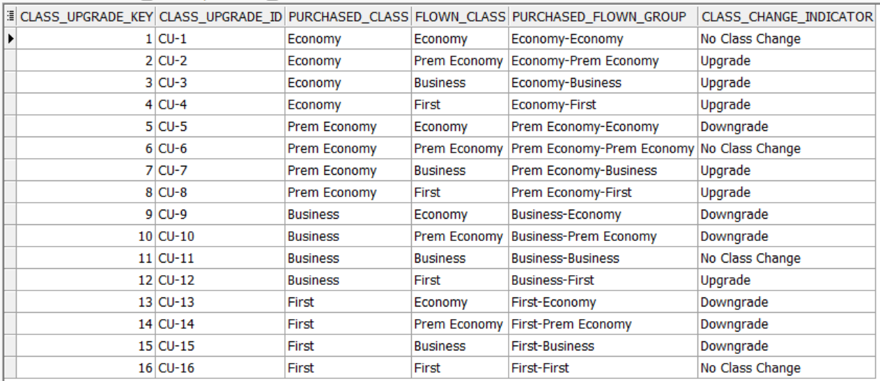
4. Flights Dimension Data

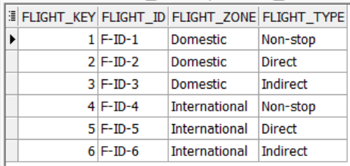

1. 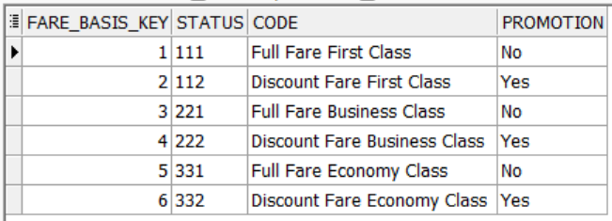Fare Basis Dimension Data
2. 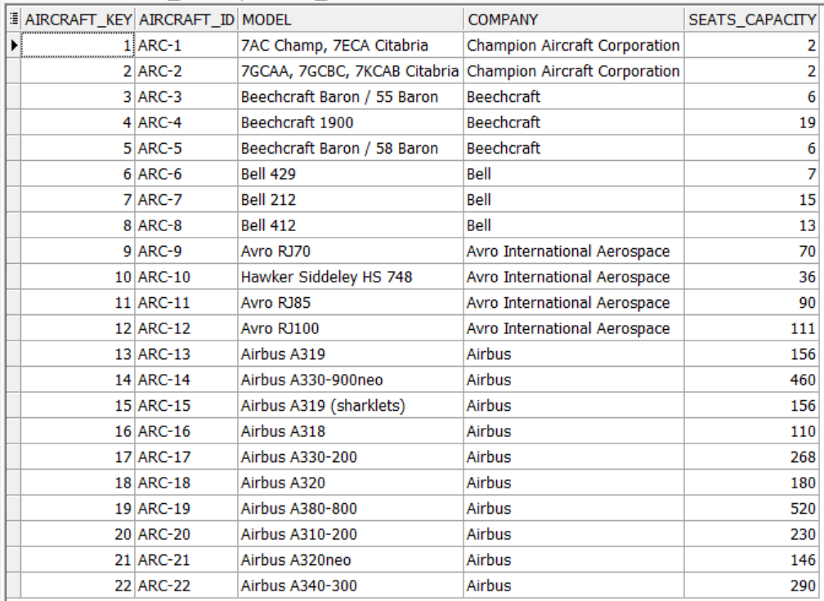Aircrafts Dimension Data
3. 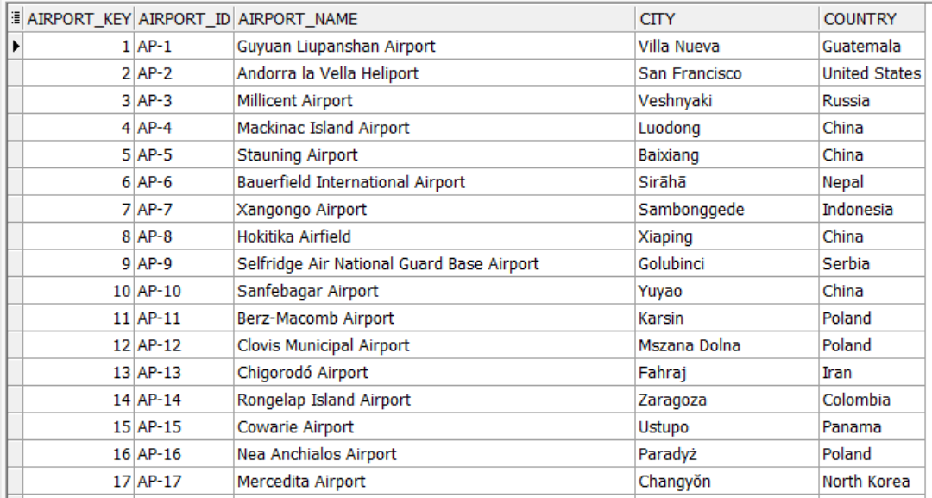Airports Dimension Data
4. Channel Dimension Data

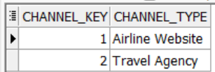

1. Payment methods Dimension Data

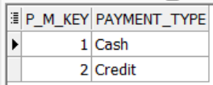

1. Interactions Dimension Data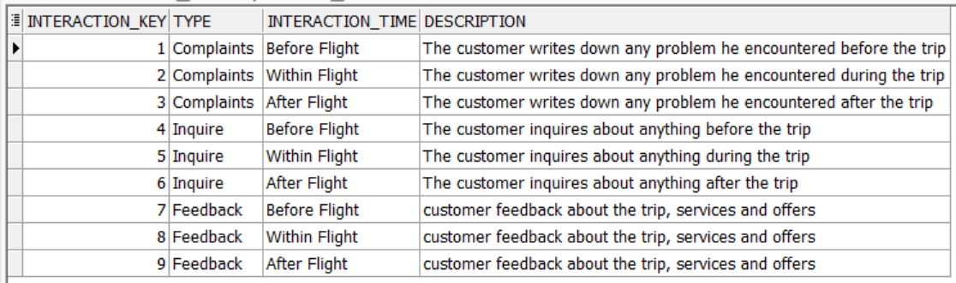
2. 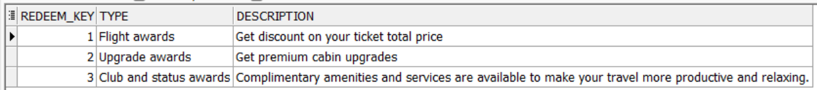Redeem Dimension Data
3. Staff Dimension Data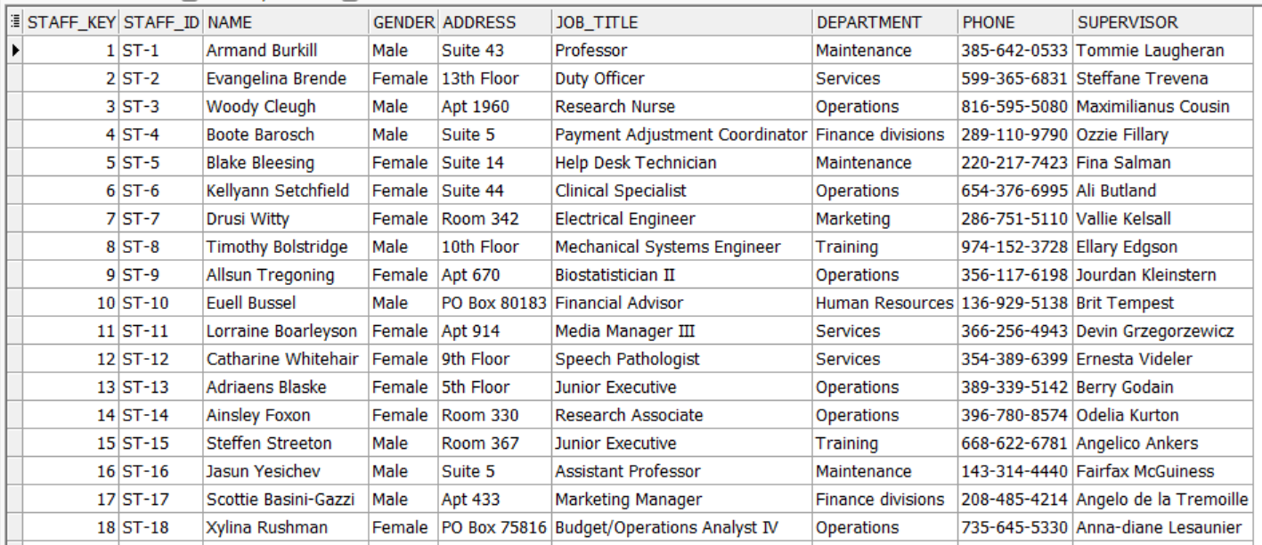
4. Date Dimension Data  
   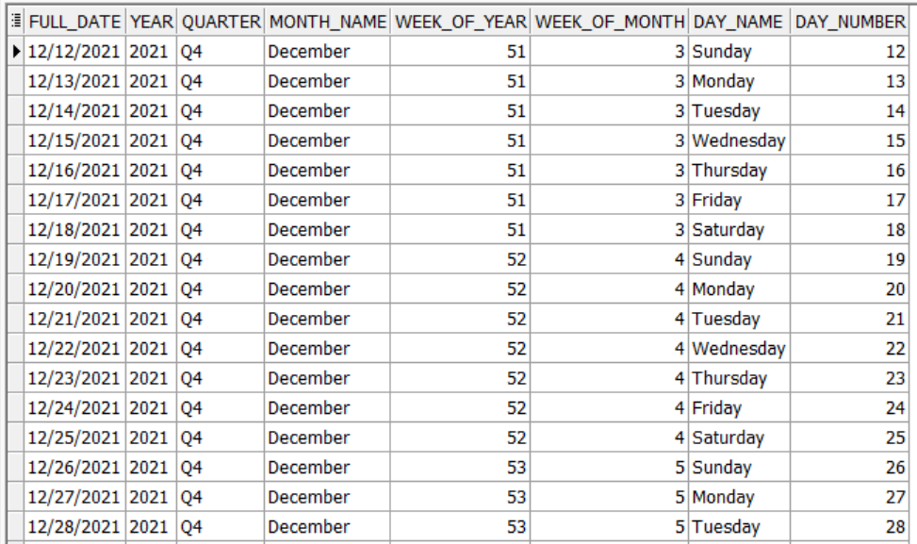
5. 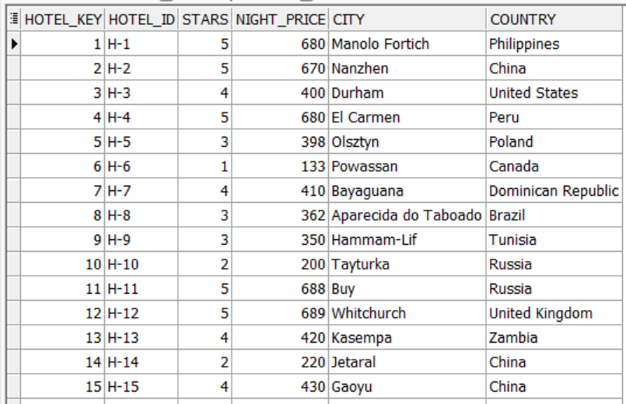Hotels Dimension Data
6. 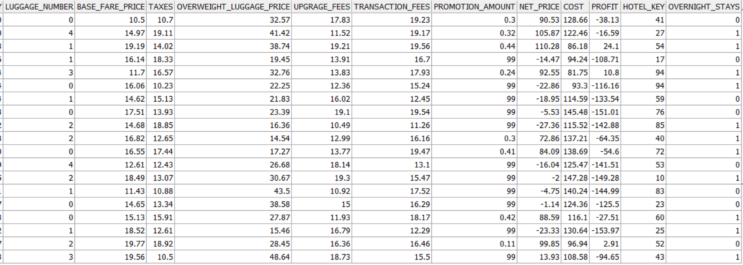Flights Activity Fact
7. Frequent Flyers Fact

1. Table

   Description automatically generatedCustomer Care Fact Data

## Insert The Measured Data into Fact Tables

1. **Insert into Flights Activity Fact [Net price & Profit]**

DECLARE

CURSOR Cur IS

SELECT Leg_key, Net_price, Base_fare_price, Taxes, Overweight_Luggage_price, Upgrage_fees, Transaction_fees, Promotion_amount, Cost, Profit

from Flights_activity_fact

FOR UPDATE OF Net_price ;

BEGIN

FOR Rec IN Cur

Loop

UPDATE Flights_activity_fact

SET Net_price = (Base_fare_price+ Taxes+nvl(Overweight_Luggage_price,0)+nvl(Upgrage_fees,0)+Transaction_fees)-nvl(Promotion_amount ,0)

WHERE CURRENT OF Cur;

UPDATE Flights_activity_fact

SET Profit =Net_price-Cost

WHERE CURRENT OF Cur;

END LOOP;

END;

1. **Insert into Customer Care Fact [Seat number]**

DECLARE

CURSOR Cur IS

SELECT Flight_key ,Seat_Number

from Customer_Care_fact

FOR UPDATE OF Seat_Number;

BEGIN

FOR Rec IN Cur

LOOP

IF (Rec.Flight_key in (1,2,3,4,5,6))

THEN

UPDATE Customer_Care_fact

SET Seat_Number = TRUNC(***dbms_random.value***(1,300),0)

WHERE CURRENT OF Cur;

END IF;

END LOOP;

END;

1. **Insert into Customer Care Fact [Problem severity & Feedback Rate]**

DECLARE

v_type VARCHAR(250);

v_time VARCHAR(250);

CURSOR Cur IS

SELECT Interaction_key ,Problem_severity

from Customer_Care_fact

FOR UPDATE OF Problem_severity;

BEGIN

FOR Rec IN Cur

LOOP

SELECT Interaction_time, TYPE

INTO v_time, v_type

FROM Interactions_DIM

WHERE Interaction_key = Rec.INTERACTION_KEY;

IF (v_time = 'Within Flight' AND v_type = 'Complaints')

THEN

UPDATE Customer_Care_fact

SET Problem_severity = 6

WHERE CURRENT OF Cur;

ELSIF (v_time = 'Before Flight' AND v_type = 'Complaints')

THEN

UPDATE Customer_Care_fact

SET Problem_severity = 2

WHERE CURRENT OF Cur;

ELSIF (v_time = 'After Flight' AND v_type = 'Complaints')

THEN

UPDATE Customer_Care_fact

SET Problem_severity = 4

WHERE CURRENT OF Cur;

ELSIF (v_time = 'Within Flight' AND v_type = 'Inquire')

THEN

UPDATE Customer_Care_fact

SET Problem_severity= 6

WHERE CURRENT OF Cur;

ELSIF (v_time = 'Within Flight' AND v_type = 'Feedback')

THEN

UPDATE Customer_Care_fact

SET Feedback_Rate = TRUNC(***dbms_random.value***(1,5),0)

WHERE CURRENT OF Cur;

ELSIF (v_time = 'Before Flight' AND v_type = 'Inquire')

THEN

UPDATE Customer_Care_fact

SET Problem_severity = 2

WHERE CURRENT OF Cur;

ELSIF (v_time = 'Before Flight' AND v_type = 'Feedback')

THEN

UPDATE Customer_Care_fact

SET Feedback_Rate= TRUNC(***dbms_random.value***(1,5),0)

WHERE CURRENT OF Cur;

ELSIF (v_time = 'After Flight' AND v_type = 'Feedback')

THEN

UPDATE Customer_Care_fact

SET Feedback_Rate = TRUNC(***dbms_random.value***(1,5),0)

WHERE CURRENT OF Cur;

ELSIF (v_time = 'After Flight' AND v_type = 'Inquire')

THEN

UPDATE Customer_Care_fact

SET Problem_severity = 4

WHERE CURRENT OF Cur;

END IF;

END LOOP;

END;

## SQL Queries to Answer Business Questions:

**1- Which Flight types do frequent flyers take more depending on their tier?**

SELECT fd.Flight_type, ff.Tier, COUNT(fa.Freq_key) AS Frequent_Flyers_number

FROM flights_activity_Fact fa

JOIN Flights_DIM fd

ON fa.Flight_key = fd.Flight_key

JOIN Frequent_flyers_Dim ff

ON ff.Freq_key = fa.Freq_key

GROUP BY fd.Flight_type, ff.Tier ;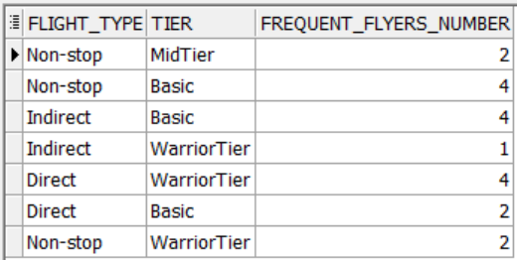

**2- Where are the most used hotels for overnights?**

SELECT hd.Country, hd.City, hd.Hotel_ID , count(fa.passenger_key)

FROM Hotels_DIM hd

JOIN flights_activity_Fact fa

ON hd.Hotel_key = fa.Hotel_key

GROUP BY hd.Country, hd.City, hd.Hotel_ID

ORDER BY hd.Country ;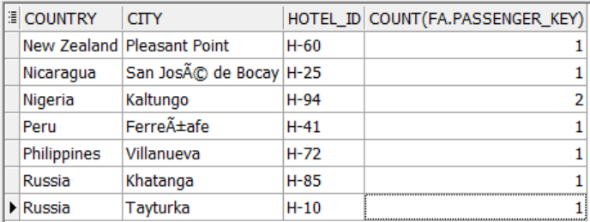

**3-** **What is the average number of nights passengers stay in each hotel?**

SELECT h.Hotel_ID, h.Stars, TRUNC(AVG(fa.overnight_stays),0) AVG_number_of_nights

FROM Hotels_DIM h

JOIN flights_activity_Fact fa

ON fa.Hotel_key = h.Hotel_key

GROUP BY h.Hotel_ID, h.Stars

ORDER BY AVG_number_of_nights DESC;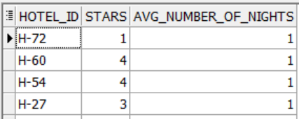

**4- What is the percentage of passengers to aircraft seats Capacity for every flight in each aircraft If there were stop stations?**

SELECT fa.Flight_key, fa.Segment_number, ac.Aircraft_key,

Round( (COUNT(fa.Passenger_key) / ac.Seats_Capacity)* 100,2) AS Capacity_Percentage

FROM flights_activity_Fact fa

JOIN Aircrafts_Dim ac

ON fa.Aircraft_key = ac.Aircraft_key

GROUP BY fa.Flight_key, fa.Segment_number, ac.Aircraft_key, ac.Seats_Capacity

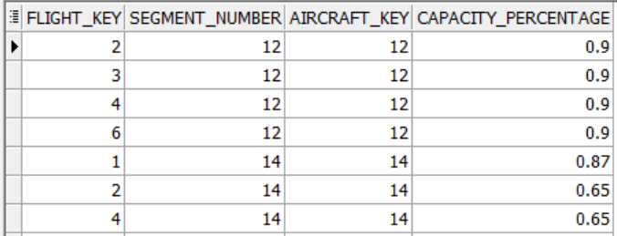ORDER BY Capacity_Percentage DESC ;

**5-** **What are the numbers of complaints based on their Problem severity per year?**

SELECT d.Year, i.TYPE, i.Interaction_time, f.Problem_severity,

COUNT (f.Problem_Severity) AS "No. of Complaints", i.Description

FROM Interactions_DIM i

JOIN Customer_Care_fact f

ON i.Interaction_key = f.Interaction_key

JOIN Date_Dim d

ON d.Full_date = f.Reservation_Ticket_Date

WHERE i.TYPE = 'Complaints'

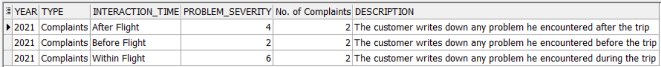GROUP BY d.YEAR, i.TYPE, i.Interaction_time, f.Problem_severity, i.Description ;

**6- Which is the most severity interaction complaint for each year?**

SELECT d.Year, i.TYPE, MAX(f.Problem_Severity)

FROM Interactions_DIM i

JOIN Customer_Care_fact f

ON i.Interaction_key = f.Interaction_key

JOIN Date_Dim d

ON d.Full_date = f.Reservation_Ticket_Date

WHERE i.TYPE = 'Complaints'

GROUP BY d.Year, i.TYPE ;

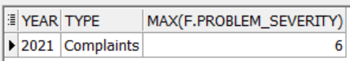

**7- Find the interaction type for inquiries and complaints and the employee who worked on it**

SELECT i.TYPE, i.Interaction_time, f.Problem_severity, st.NAME AS Customer_Services_name

FROM Interactions_DIM i

JOIN Customer_Care_fact f

ON i.Interaction_key = f.Interaction_key

JOIN Staff_Dim st

ON f.Staff_key = st.Staff_key

WHERE i.TYPE = 'Complaints' OR i.Type = 'Inquire'

ORDER BY i.TYPE;

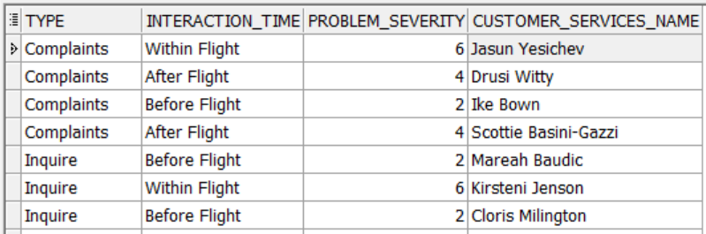

**8- What are the numbers of Feedbacks Ratings based on their degree of rate per year?**

SELECT d.Year, i.TYPE, f.Feedback_Rate,

COUNT(f.Feedback_Rate) AS "No. of Feedback Ratings", i.Description

FROM Interactions_DIM i

JOIN Customer_Care_fact f

ON i.Interaction_key = f.Interaction_key

JOIN Date_Dim d

ON d.Full_date = f.Reservation_Ticket_Date

WHERE i.TYPE = 'Feedback'

GROUP BY d.Year, i.TYPE, f.Feedback_Rate, i.Description

ORDER BY COUNT(f.Feedback_Rate) DESC ;

**9- Which Reservation Channel contributes more to the sales of the company?**

SELECT ch.Channel_Type AS "Reservation Channel", SUM(fa.Net_price) AS Total_sales

FROM flights_activity_Fact fa

JOIN Channels_Dim ch

ON fa.Channel_key = ch.channel_key

GROUP BY ch.Channel_Type

ORDER BY Total_sales DESC;

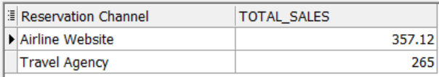

**10- What are the profits of the company per Quarter?**

SELECT d.Year, d.Quarter, SUM(fa.Profit) AS "Profit"

FROM flights_activity_Fact fa

JOIN Date_Dim d

ON fa.Reservation_Ticket_Date = d.full_date

GROUP BY d.Year, d.Quarter ;

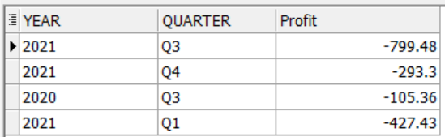

## Indexes For the Data Warehousing

1. Introduction

Data warehouse solutions have recently grown in significance for decision-makers. Most of the queries against a large data warehouse are complex and iterative. The ability to answer these queries efficiently is a critical issue in the data warehouse environment. Indexing is a way to optimize the performance by minimizing the number of disk accesses required when a query is processed. If the right index structures are built on columns, the performance of queries, especially ad hoc queries, will be greatly enhanced. In this report, we discuss indexing techniques being used. Indexing in a data warehouse may be tricky; too few indexes will result in quick data loads but delayed query responses, while too many indexes will affect data loads slow down and storage requirements go up, but query response is good.

1. Factors used to determine which indexing technique should be built on a Column

Characteristics of indexed column

1. A column has its own characteristics which we can use to choose a proper index. These characteristics are given below:  
   • Cardinality data: The cardinality data of a column is the number of distinct values in the column. It is better to know that the cardinality of an indexed column is low or high since an indexing technique may work efficiently only with either low cardinality or high cardinality.  
   • Distribution: The distribution of a column is the occurrence frequency of each distinct value of the column. The column distribution guides us to determine which index type we should take.  
   • Value range: The range of values of and indexed column guides us to select an appropriate index type. For example, if the range of a high cardinality column is small, an indexing technique based on bitmap should be used. Without knowing this information, we might use a B-Tree resulting in a degradation of system performance.
2. Understanding the data and the usage in the SQL language. Knowing the columns that will be queried helps us choose appropriate index types for them. For example, which columns will likely be a part of the selection list, join constraints, application constraints, the ORDER BY clause, or the GROUP BY clause?
3. Indexing Techniques
   1. B+-Tree indexes

The most used data structures to improve query processing time in operational databases. A B+-Tree indexes on an attribute C of a relation R is a balanced tree providing associative access to the tuples of R on the basis of the values of the C key. The leaves of this tree are linked to each other and store the pointers to the disk blocks containing tuples. Internal nodes create a sort of map to find key values quickly. The top level of the index is called the root. The lowest level is called the leaf node. All other levels in between are called branches. Both the root and branch contain entries that point to the next level in the index. Leaf nodes consisting of the index key and pointers pointing to the physical location in which the corresponding records are stored.

* 1. Bitmap Index  
     The bitmap representation is an alternate method of the row ids representation. It is simple to represent and uses less space and CPU efficient than row ids. when the number of distinct values of the indexed column is low. The indexes improve complex query performance by applying low-cost Boolean operations such as OR, AND, and NOT in the selection predicate on multiple indexes at one time to reduce search space before going to the primary source data. Many variations of the Bitmap Index (Pure Bitmap Index, Encoded Bitmap, etc.) aiming to reduce space requirement as well as improve query performance.

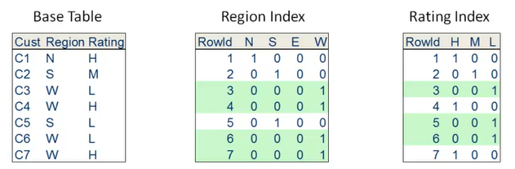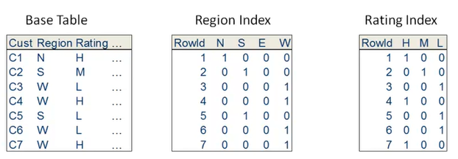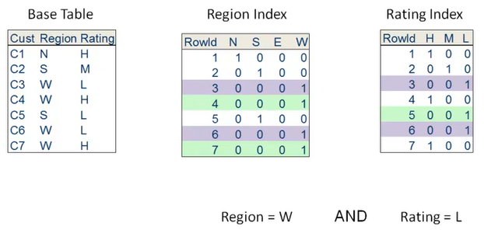

SELECT Customers FROM Base Table WHERE Region = W AND Rating = L

* 1. Join and Star Indexes

Even though star schemata explicitly aim at reducing the number of joins necessary to retrieve data, joins still mainly determine the cost of OLAP queries. Researchers have been working for a long time to reduce the join execution time. To do this, they have developed more efficient join algorithms.

A join index between two relations $R_{1}$ and $R_{2}$. stores couples of tuples RIDS that fulfill the $C_{1}$ <operator> $C_{2}$: join predicate between two attributes $C_{1}∈R_{1}$ and $C_{2}∈R_{2}$.

Join indexes strongly improve performance because they preprocess and explicitly store RIDs of the matching tuples in two relations. To check for the tuples to fulfill your join predicate, you no longer need to check all the combinations, but you need to scan your index.

1. References

**Book:**

[Matteo Golfarelli](https://www.amazon.com/Matteo-Golfarelli/e/B00279KCKU/ref=dp_byline_cont_book_1), *Data Warehouse Design, Modern Principles and Methodologies*

**Paper:**

*Indexing Techniques for Data Warehouses’ Queries*

*A Comparative Study of Indexing Techniques in Data Warehouse*

*Indexing Techniques to Enhance the Performance of Data Warehouses*

*The impact of indexes on data warehouse performance*

**Website:**

<https://docs.oracle.com/cd/B12037_01/server.101/b10736/indexes.htm#i1006549>